**• What is OOP? List OOP concepts**

Ans: - Object-oriented programming- as the name suggests uses objects in programming. Object-oriented programming aims to implement real-world entities like inheritance, hiding, polymorphism, etc. in programming. The main aim of OOP is to bind together the data and the functions that operate on them so that no other part of the code can access this data except that function.

There are some basic concepts that act as the building blocks of OOPs i.e.

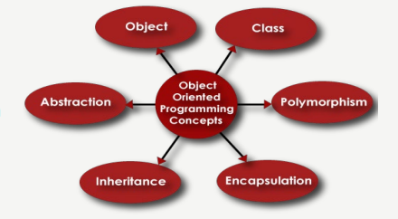

1.Class

2.Object

3.Encapsulation

4.Abstraction

5.Polymorphism

6.Inheritance

7.Dynamic Binding

**• What is the difference between OOP and POP?**

|  |  |  |
| --- | --- | --- |
| **Feature** | **Object Oriented Programming (C++)** | **Procedural Programming (C Language)** |
| Key Focus | Object and their interactions | Procedures and functions |
| Data Management | Data and behavior are encapsulation in objects | Data and behavior are separate entities |
| Abstraction | Encourages the use of abstract classes and interfaces | Does not emphasize abstraction |
| Inheritance | Supports inheritance, allowing classes to inherit properties and methods | Does not support inheritance |
| Polymorphism | Allow objects of different types to be treated as the same type | Does no provide inherent polymorphism |
| Code Reusability | High level of code reusability thought inheritance and composition | Relies on functions and subroutines for code reusability |
| Code Organization | Follows of modular approach, with objects as self-contained modules | Relies on function and procedures for code organization |
| Flexibility | Provides flexibility through polymorphism and dynamic binding | Relies on structured programming, offering less flexibility |
| Complexity Management | Encourages managing complexity through encapsulation and abstraction | Manages complexity through modular code organization and stepwise design |
| Real-World Modeling | Well-suited for modelling real-world entities and their interactions | May not align well with real-world modelling, focusing more on processes |